Cisco AI Defense
Install/Validation

Table of Contents
Table of Contents 2
1. Overview 4
1.1 What is Cisco AI Defense? 4
1.2 Hybrid Deployment Architecture 4
1.3 Environment Details 4
1.4 Components Deployed 4
2. Prerequisites 6
2.1 Hardware used 6
2.2 Software Prerequisites 6
3. Pre-Installation Validation 6
3.1 Validate GPU Nodes 6
Check node labels for GPU presence: 6
Check allocatable GPU resources: 6
Check GPU Operator pods are Running: 7
Run GPU smoke test: 7
3.2 Validate Cilium CNI 7
4. Installation Steps 9
Step 1: Label GPU Worker Nodes 9
Apply the label: 9
Verify labels were applied: 9
Step 2: Configure Security Context Constraints (SCC) 9
Grant anyuid SCC to AI Defense service accounts: 9
Step 3: Verify cert-manager 10
Check if cert-manager is already installed: 10
Install cert-manager (if not already installed): 10
Verify all three pods are Running: 11
Step 4: Create AI Defense Connector in SCC Portal 11
Copy script to bastion: 12
Step 5: Run the AI Defense Installation Script 12
Run the installation script: 12
Expected preflight checks (all must pass): 12
Expected final output: 13
Step 6: Apply OpenShift Routes 13
Verify routes were created: 14
Issue 1: Triton GPU Pods Failing with Permission Denied 14
Symptom: 14
Root Cause: 14
Resolution: 14
Issue 2: Config Synchronizer Pods Pending - LVM Storage Failed 15
Symptom: 15
Root Cause: 15
Resolution: 15
Issue 3: Gemma Model Failing to Load (TORCH_CUDA_ARCH_LIST) 16
Symptom: 16
Root Cause: 16
Resolution: 16
Issue 4: DNS Pointing to Wrong IP 16
Symptom: 16
Root Cause: 16
Resolution: 17
6. Post-Installation Validation 18
6.1 Validate All Pods are Running 18
6.2 Validate Runtime Protection 18
6.3 Validate AI Validation Service 18
6.4 Validate GPU Allocation to Triton Pods 18
6.5 Validate Routes 19
6.6 Validate Connector Status in SCC Portal 19
6.7 Quick No-Error Check 20
7.1 Accessing AI Defense 20
7.3 Node Label Persistence 20
7.4 Gemma Environment Variable 21
7.5 Upgrading AI Defense 21
7.6 Uninstalling AI Defense 21
8. Quick Reference 22
8.1 Key Commands 22
8.2 Key Environment Details 22

1. Overview

1.1 What is Cisco AI Defense?
Cisco AI Defense is an enterprise AI security platform that protects organizations against threats introduced by the development, deployment, and usage of AI applications. It provides three core capabilities:
- Discovery: Identifies all AI workloads, applications, models, data and user access across distributed environments.
- Detection: Scans AI models and applications for security vulnerabilities including prompt injection susceptibility, data leakage risks, and model behavior issues.
- Runtime Protection: Sits inline as a proxy and inspects every AI request and response in real time, blocking prompt injections, PII leakage, toxic content, and other threats.

1.2 Hybrid Deployment Architecture
This runbook covers the Hybrid Deployment model where the AI Defense data plane is deployed on-premises on the Cisco AI Pod (OpenShift cluster), while the control plane (management UI and policy engine) remains in Cisco's SaaS cloud at security.cisco.com.

1.3 Environment Details

Platform: | Cisco UCS X-Series / AI Pod-1
OCP Version | 4.19.6
AI Defense Ver | 26.3.2
GPU | 2x NVIDIA H100 NVL (2 nodes)
CNI | Cilium

1.4 Components Deployed
Component | Type | Purpose
ai-defense-apigateway | Core Service | Entry point for all API inspection requests
ai-defense-proxy | Core Service | Intercepts and inspects LLM traffic in real time
ai-defense-orchestrator | Core Service | Coordinates all AI Defense components
firewall | Core Service | Enforces allow/block policies on AI traffic
detection-server | Detection | Core ML detection coordinator
triton-gemma-3-4b-it | GPU - Validation | Gemma 3 4B model for generative validation
modernbert-pi-tox-triton-trt | GPU - Runtime | Detects prompt injection and toxic content
modernbert-privacy-triton-trt | GPU - Runtime | Detects privacy violations
pi-mmbert-v2-triton-trt | GPU - Runtime | Multimodal prompt injection detection
presidio-pii-analyzer | Detection | Detects Personally Identifiable Information
pii-extractor | Detection | Extracts and flags PII in requests
yara-server | Detection | Rule-based pattern detection engine
generative-validation-service | Validation | Validates AI model outputs
ai-defense-config-synchronizer | Platform | Keeps config in sync across replicas (x3)
ai-defense-onprem-gateway | Platform | Communication back to Cisco SaaS cloud
ai-defense-token-validator | Platform | Validates authentication tokens
ai-defense-forwarder | Platform | Forwards events to Cisco cloud
replicated | Platform | Manages configuration replication

2. Prerequisites

2.1 Hardware used
Requirement | Value
Platform | Cisco UCS X-Series (UCS 9508 Chassis)
GPU Worker Nodes | Minimum 2 nodes with NVIDIA H100 NVL GPUs
GPU per Node | 1x H100 NVL (95GB HBM)
Storage | NVMe drives on worker nodes for LVM storage
Network | 10.6.41.0/24 management/data VLAN

2.2 Software Prerequisites
Component | Version | Status
Red Hat OpenShift | 4.19.6 | Required
Cilium CNI | Isovalent | Required
NVIDIA GPU Operator | V25.10.1 | Required
cert-manager | v1.18.2 | Required
Helm | v3.13.3 | Required on bastion
LVM Storage (lvms-nvme) | topolvm.io | Required for PVC provisioning
Cisco SCC Account | security.cisco.com | Required for AI Defense license

3. Pre-Installation Validation
Before beginning the AI Defense installation, validate the following components are healthy. Do NOT proceed if any check fails.

3.1 Validate GPU Nodes
Verify that GPU worker nodes are visible to the cluster and GPUs are allocatable.

Check node labels for GPU presence:
oc get nodes -L nvidia.com/gpu.present,nvidia.com/gpu.count

Check allocatable GPU resources:
oc get nodes -o json | jq '.items[] | {name: .metadata.name, allocatable: .status.allocatable["nvidia.com/gpu"]}'

Check GPU Operator pods are Running:
oc get pods -n gpu-operator -o wide

Run GPU smoke test:
This creates a test pod that requests 1 GPU and runs nvidia-smi to confirm the GPU is accessible from a container:
cat <<EOF | oc apply -f -
apiVersion: v1
kind: Pod
metadata:
name: gpu-test
spec:
restartPolicy: Never
containers:
- name: cuda-test
image: registry.access.redhat.com/ubi8/ubi:latest
command: ["nvidia-smi"]
resources:
limits:
nvidia.com/gpu: 1
EOF

# Watch pod status
oc get pod gpu-test -w

# Check output once Completed
oc logs gpu-test
[root@aipod1-bastion ~]# oc logs gpu-test
Wed Mar 18 22:28:59 2026
+-----------------------------------------------------------------------------------------+
| NVIDIA-SMI 580.105.08 Driver Version: 580.105.08 CUDA Version: 13.0 |
+-----------------------------------------+------------------------+----------------------+
| GPU Name Persistence-M | Bus-Id Disp.A | Volatile Uncorr. ECC |
| Fan Temp Perf Pwr:Usage/Cap | Memory-Usage | GPU-Util Compute M. |
| | | MIG M. |
|=========================================+========================+======================|
| 0 NVIDIA H100 NVL On | 00000000:E1:00.0 Off | 0 |
| N/A 31C P0 57W / 400W | 0MiB / 95830MiB | 0% Default |
| | | Disabled |
+-----------------------------------------+------------------------+----------------------+

+-----------------------------------------------------------------------------------------+
| Processes: |
| GPU GI CI PID Type Process name GPU Memory |
| ID ID Usage |
|=========================================================================================|
| No running processes found |
+-----------------------------------------------------------------------------------------+

# Cleanup
oc delete pod gpu-test
Expected output: nvidia-smi table showing NVIDIA H100 NVL, Driver Version 580.x, 95830MiB memory.

NOTE
GPU validation was completed successfully on this deployment. Output showed NVIDIA H100 NVL with Driver Version 580.105.08 and 95830MiB of HBM memory available.

3.2 Validate Cilium CNI
Confirm that Cilium is healthy on all nodes, especially the new GPU worker nodes.
# Check all Cilium pods are Running
[root@aipod1-bastion ~]# oc get pods -n cilium -o wide
NAME READY STATUS RESTARTS AGE IP NODE NOMINATED NODE READINESS GATES
cilium-b5w8h 1/1 Running 1 131m 10.6.41.14 ocp-aipod1-wrk1.gruveai.com <none> <none>
cilium-b9pkr 1/1 Running 1 131m 10.6.41.15 ocp-aipod1-wrk2.gruveai.com <none> <none>
cilium-envoy-knwvw 1/1 Running 0 18h 10.6.41.11 aipod1-ctrl1.gruveai.com <none> <none>
cilium-envoy-qft6j 1/1 Running 1 3h53m 10.6.41.14 ocp-aipod1-wrk1.gruveai.com <none> <none>
cilium-envoy-s2jfl 1/1 Running 1 3h43m 10.6.41.15 ocp-aipod1-wrk2.gruveai.com <none> <none>
cilium-envoy-ts8dl 1/1 Running 0 18h 10.6.41.13 aipod1-ctrl3.gruveai.com <none> <none>
cilium-envoy-vz4qh 1/1 Running 0 18h 10.6.41.12 aipod1-ctrl2.gruveai.com <none> <none>
cilium-gh8fd 1/1 Running 0 131m 10.6.41.13 aipod1-ctrl3.gruveai.com <none> <none>
cilium-nzntz 1/1 Running 0 131m 10.6.41.12 aipod1-ctrl2.gruveai.com <none> <none>
cilium-operator-b75cdd957-44l8d 1/1 Running 0 18h 10.6.41.11 aipod1-ctrl1.gruveai.com <none> <none>
cilium-operator-b75cdd957-rmtm8 1/1 Running 0 18h 10.6.41.13 aipod1-ctrl3.gruveai.com <none> <none>
cilium-pqh2l 1/1 Running 0 131m 10.6.41.11 aipod1-ctrl1.gruveai.com <none> <none>
clife-controller-manager-7bcc8778fd-p9sh6 1/1 Running 0 17h 10.6.41.11 aipod1-ctrl1.gruveai.com <none> <none>
hubble-relay-c8d7b869f-rl9cb 1/1 Running 0 17h 10.0.1.45 aipod1-ctrl1.gruveai.com <none> <none>
hubble-ui-6445786767-ps2xl 2/2 Running 0 18h 10.0.1.74 aipod1-ctrl1.gruveai.com <none> <none>
[root@aipod1-bastion ~]# oc get ds cilium -n kube-system
Error from server (NotFound): daemonsets.apps "cilium" not found
[root@aipod1-bastion ~]# oc get ds cilium -n cilium
NAME DESIRED CURRENT READY UP-TO-DATE AVAILABLE NODE SELECTOR AGE
cilium 5 5 5 5 5 kubernetes.io/os=linux 84

4. Installation Steps

Step 1: Label GPU Worker Nodes
AI Defense uses a node label node_group=dps to identify which nodes should host its workloads. This ensures all GPU-intensive AI Defense pods are scheduled exclusively on the dedicated H100 worker nodes and not on control plane nodes.

NOTE
'dps' stands for Data Protection Service. Without this label, AI Defense pods may attempt to schedule on control plane nodes which have no GPUs, causing them to fail.

Apply the label:
oc label node ocp-aipod1-wrk1.gruveai.com node_group=dps --overwrite
oc label node ocp-aipod1-wrk2.gruveai.com node_group=dps --overwrite

Verify labels were applied:
oc get node ocp-aipod1-wrk1.gruveai.com -o jsonpath='{.metadata.labels.node_group}{"\n"}'
oc get node ocp-aipod1-wrk2.gruveai.com -o jsonpath='{.metadata.labels.node_group}{"\n"}'
dps
dps
Expected output: dps (on each line)

Step 2: Configure Security Context Constraints (SCC)
OpenShift has a stricter security model than standard Kubernetes. By default it blocks containers from running as root or as arbitrary user IDs. AI Defense containers are built to run as specific user IDs internally. This step grants the required permissions to three AI Defense service accounts.

NOTE
anyuid is a built-in OpenShift SCC policy that allows a container to run as any user ID including root. This is scoped only to specific service accounts - not granted cluster-wide.

Grant anyuid SCC to AI Defense service accounts:
oc adm policy add-scc-to-user anyuid -z pii-analyzer-serviceaccount
oc adm policy add-scc-to-user anyuid -z rde-operator
oc adm policy add-scc-to-user anyuid -z ai-defense-orchestrator
Expected output for each command:
clusterrole.rbac.authorization.k8s.io/system:openshift:scc:anyuid added: "pii-analyzer-serviceaccount"
clusterrole.rbac.authorization.k8s.io/system:openshift:scc:anyuid added: "rde-operator"
clusterrole.rbac.authorization.k8s.io/system:openshift:scc:anyuid added: "ai-defense-orchestrator"

WARNING
IMPORTANT: After installation, you will also need to grant anyuid to the 'default' service account in the ai-defense-onprem namespace. The Triton GPU model containers use the default service account and require anyuid to create model symlinks. See the Troubleshooting section for details.

Step 3: Verify cert-manager
cert-manager is a Kubernetes-native certificate management tool that automates the creation, renewal, and management of TLS certificates. AI Defense requires cert-manager to handle internal service-to-service TLS certificates. Without it, the Helm chart deployment will fail immediately.

cert-manager provides three components:
- cert-manager: Core controller that watches for certificate requests and fulfills them.
- cert-manager-cainjector: Injects CA data into webhooks and other resources that need it.
- cert-manager-webhook: Validates certificate requests before cert-manager acts on them.

Check if cert-manager is already installed:
helm list -n cert-manager
oc get pods -n cert-manager
If cert-manager is already installed and all pods are Running, skip the install command below.

Install cert-manager (if not already installed):
helm install cert-manager oci://quay.io/jetstack/charts/cert-manager \
--version v1.18.2 \
--namespace cert-manager \
--create-namespace \
--set crds.enabled=true

Verify all three pods are Running:
oc get pods -n cert-manager
Expected output:
NAME READY STATUS RESTARTS AGE
cert-manager-58dd99f969-xztjz 1/1 Running 0 42d
cert-manager-cainjector-55cd9f77b5-t4fn8 1/1 Running 0 43d
cert-manager-webhook-7987476d56-cvnpg 1/1 Running 0 43d

SUCCESS
cert-manager v1.18.2 was already installed from a previous deployment and all 3 pods were Running. No action was needed.

Step 4: Create AI Defense Connector in SCC Portal
The Helm install commands and API key are generated by the Cisco Security Cloud Control (SCC) portal. You must create a connector first to get these values.

- Navigate to https://security.cisco.com and log in with your Cisco credentials.
- Go to Administration > Hybrid Deployments from the left navigation menu.
- Click the '+ Start deployment' button in the top right corner.
- Fill in the connector details:
  - Name: gruve-aipod1-onprem
  - Services: Select both Validation and Runtime
  - GPU Selection: NVIDIA H100
  - Install on Single GPU: No (you have 2 worker nodes with H100s)
- On the 'Install AI Defense services' screen:
  - API key name: gruve-aipod1-key
  - Expiration: Never expires
  - Click 'Generate API Key'
  - IMPORTANT: Copy the API key immediately - it is only shown once
- Click 'Download' to get the latest aidefense-connector-installation.sh script.
- Copy the downloaded script to your bastion server.

WARNING
The API key is shown only once when generated. If you lose it you must generate a new one. Store it securely before closing the portal page.

Copy script to bastion:
# Make script executable
chmod +x ~/aidefense-connector-installation.sh

Step 5: Run the AI Defense Installation Script
Installation script automates the full Helm deployment. It performs the following steps automatically:
- Checks prerequisites (Helm, kubectl, cluster connectivity)
- Creates the ai-defense-onprem namespace
- Authenticates with the Cisco Helm chart registry
- Installs and runs preflight checks against your cluster
- Creates the API key secret in the cluster
- Deploys all AI Defense components via Helm

Run the installation script:
bash ~/aidefense-connector-installation.sh --apikey <your-api-key>
The script will display colored output showing each step. The preflight check screen shows a terminal UI - press 'q' to quit once all checks show green checkmarks.

Expected preflight checks (all must pass):
Preflight Check | What It Verifies
Kubernetes distribution | OpenShift is a supported distribution
Required Kubernetes Version | OCP 4.18 or higher is installed
Node status check | All nodes are in Ready state
Verify dps node group exists with at least 2 nodes | node_group=dps label applied to workers
NVIDIA GPU Operator installation status | GPU Operator is running
Default storage class check | A default storage class exists
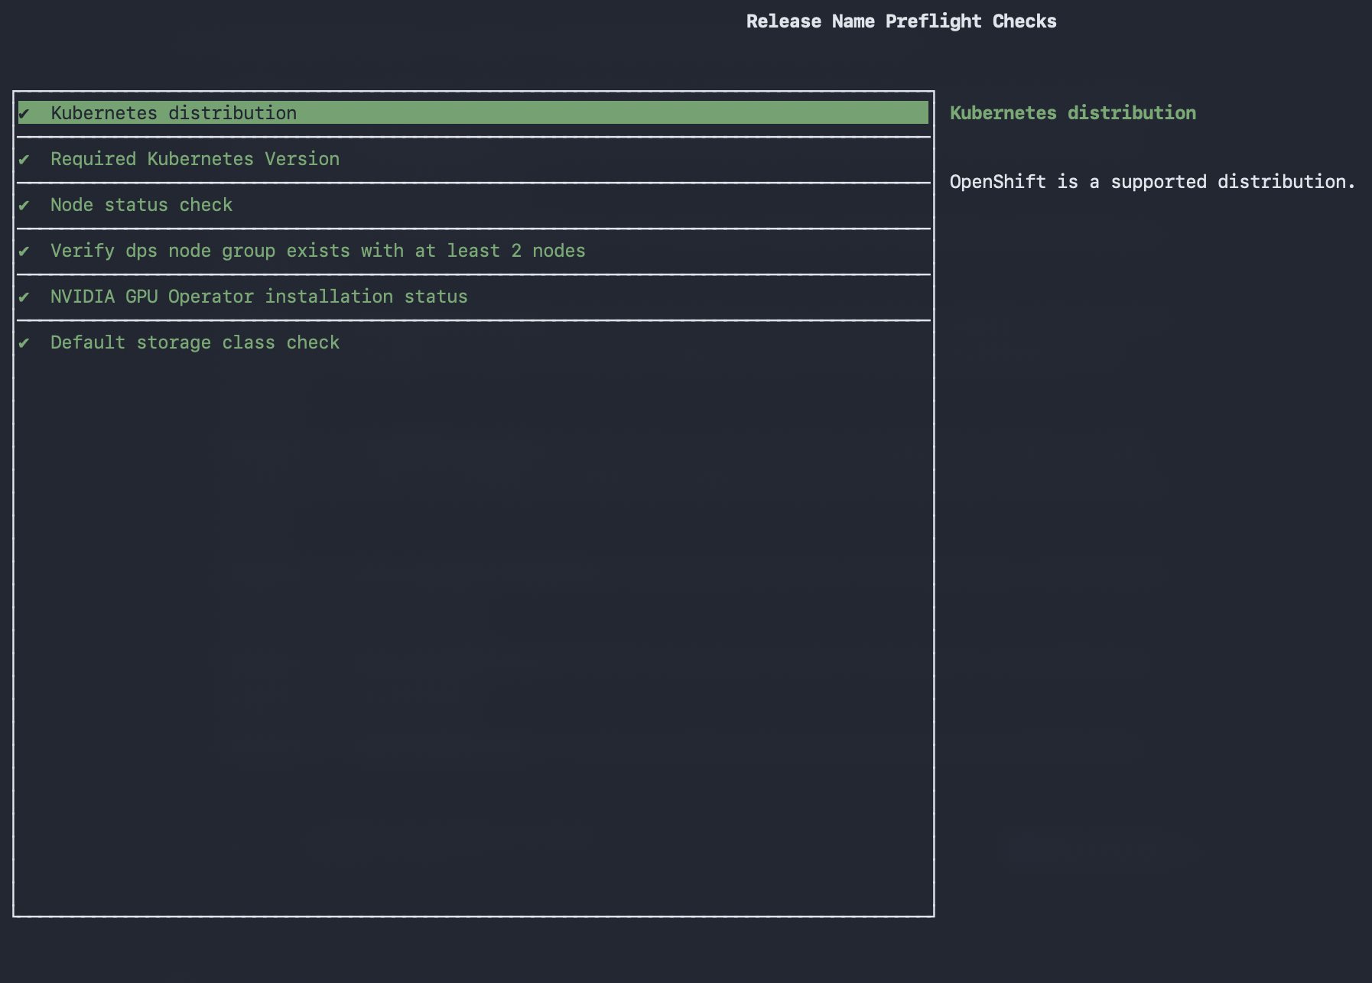

Expected final output:
NAME: ai-defense-onpremises
LAST DEPLOYED: Wed Mar 18 18:14:08 2026
NAMESPACE: ai-defense-onprem
STATUS: deployed
REVISION: 1
[SUCCESS] AI Defense deployment completed successfully

Step 6: Apply OpenShift Routes
Two Routes expose AI Defense services to the outside network. The routes in this installation are pre-configured for *.gruveai.com.

The two routes serve different purposes:
- route-apigw.yaml: Exposes /api/v1/inspect path to the ai-defense-apigateway service. Used for API-based disposition queries.
- route-proxy.yaml: Exposes / (root path) to the ai-defense-proxy-service. Used for proxying AI application traffic through AI Defense.

oc apply -f /root/ocp-aipod1/ai-defense/route-apigw.yaml
oc apply -f /root/ocp-aipod1/ai-defense/route-proxy.yaml

Verify routes were created:
oc get routes -n ai-defense-onprem
Expected output:
NAME HOST/PORT PATH SERVICES PORT TERMINATION WILDCARD
api-gateway-inspect aid-rte-onprem.gruveai.com /api/v1/inspect ai-defense-apigateway 8080 edge/Redirect None
proxy-root aid-rte-onprem.gruveai.com / ai-defense-proxy-service 8080 edge/Redirect None

5. Troubleshooting — Issues Encountered During Installation
The following issues were encountered during installation on this environment and their resolutions are documented here for future reference.

Issue 1: Triton GPU Pods Failing with Permission Denied

Symptom:
modernbert-pi-tox-triton-trt 0/1 CrashLoopBackOff
modernbert-privacy-triton-trt 0/1 CrashLoopBackOff
pi-mmbert-v2-triton-trt 0/1 CrashLoopBackOff

Root Cause:
The Triton model server containers attempt to create a symlink at /models/classification/1/model.plan during startup. OpenShift's default restricted-v2 SCC blocked this operation because the container needed to run with elevated permissions to write to that directory. All three Triton pods were using the 'default' service account which had not been granted anyuid.
# Error in pod logs:
ln: failed to create symbolic link '/models/classification/1/model.plan': Permission denied

# SCC confirmation:
oc get pod modernbert-pi-tox-triton-trt-xxx -n ai-defense-onprem \
-o jsonpath='{.metadata.annotations.openshift\.io/scc}{"\n"}'
# Output: restricted-v2 <-- too restrictive

Resolution:
Grant anyuid SCC to the default service account in the ai-defense-onprem namespace, then delete the crashing pods so they restart with the new permissions:
# Grant anyuid to default service account
oc adm policy add-scc-to-user anyuid -z default -n ai-defense-onprem

# Delete crashing pods to force restart with new permissions
oc delete pod modernbert-pi-tox-triton-trt-<pod-id> -n ai-defense-onprem
oc delete pod modernbert-privacy-triton-trt-<pod-id> -n ai-defense-onprem
oc delete pod pi-mmbert-v2-triton-trt-<pod-id> -n ai-defense-onprem

Issue 2: Config Synchronizer Pods Pending - LVM Storage Failed

Symptom:
ai-defense-config-synchronizer-v2-0 0/1 Pending
ai-defense-config-synchronizer-v2-1 0/1 Pending
ai-defense-config-synchronizer-v2-2 0/1 Pending

# PVC error:
Warning NotEnoughCapacity lvms-pvc-controller Requested storage (1Gi) is greater than available capacity on any node ().

Root Cause:
The LVM storage cluster (lvm-nvme) was in a Failed state. The vg-manager DaemonSet that manages NVMe volume groups had a node selector of lvms-nvme=true, but the new GPU worker nodes (ocp-aipod1-wrk1 and ocp-aipod1-wrk2) never received this label when they joined the cluster. As a result, the vg-manager had DESIRED: 0 and no storage could be provisioned.
# Check LVM cluster status:
oc get lvmcluster -n openshift-storage
# Output: lvm-nvme Failed

# Check DaemonSet:
oc get daemonset -n openshift-storage
# Output: vg-manager 0 0 0 0 0 lvms-nvme=true 72d
# DESIRED=0 means no nodes have the required label

Resolution:
Label both GPU worker nodes with lvms-nvme=true so the vg-manager DaemonSet can schedule on them:
oc label node ocp-aipod1-wrk1.gruveai.com lvms-nvme=true
oc label node ocp-aipod1-wrk2.gruveai.com lvms-nvme=true

# Verify DaemonSet is now scheduling:
oc get daemonset -n openshift-storage
# Expected: vg-manager 2 2 2 2 2 lvms-nvme=true

# Verify vg-manager pods are running on workers:
oc get pods -n openshift-storage -o wide

WARNING
This label must be re-applied if new worker nodes are added to the cluster in the future. Consider adding lvms-nvme=true to the MachineConfig for worker nodes to make it permanent.

Issue 3: Gemma Model Failing to Load (TORCH_CUDA_ARCH_LIST)

Symptom:
triton-gemma-3-4b-it 0/1 CrashLoopBackOff

# Error in logs:
error: creating server: Internal - failed to load all models

Root Cause:
The Gemma 3 4B Triton container needed the TORCH_CUDA_ARCH_LIST environment variable set to 9.0 for the NVIDIA H100 GPU (Hopper architecture, compute capability 9.0). Without this, PyTorch could not correctly target the GPU architecture for model compilation.

Resolution:
Set the environment variable on the deployment. This change is persistent - it modifies the Deployment object in Kubernetes so all future pod restarts will use this value:
oc set env deploy/triton-gemma-3-4b-it -n ai-defense-onprem TORCH_CUDA_ARCH_LIST=9.0
oc rollout restart deploy/triton-gemma-3-4b-it -n ai-defense-onprem

WARNING
If AI Defense is upgraded via Helm in the future, this environment variable may be overwritten. Re-apply it after any Helm upgrade: oc set env deploy/triton-gemma-3-4b-it -n ai-defense-onprem TORCH_CUDA_ARCH_LIST=9.0

Issue 4: DNS Pointing to Wrong IP

Symptom:
curl to https://aid-rte-onprem.gruveai.com returns 'Application is not available'.

Root Cause:
The DNS record for aid-rte-onprem.gruveai.com was pointing to 10.6.41.37 instead of the correct OpenShift Ingress VIP 10.6.41.17.
# Diagnose:
dig aid-rte-onprem.gruveai.com
# Showed: aid-rte-onprem.gruveai.com. 3600 IN A 10.6.41.37 (WRONG)
# Should be: 10.6.41.17 (OCP Ingress VIP)

Resolution:
Update the DNS A record on the internal DNS server (10.6.1.11):
aid-rte-onprem.gruveai.com A 10.6.41.17
Temporary workaround (Windows): Add to C:\Windows\System32\drivers\etc\hosts:
10.6.41.17 aid-rte-onprem.gruveai.com

6. Post-Installation Validation

6.1 Validate All Pods are Running
oc get pods -n ai-defense-onprem
All 20 pods must show 1/1 Running with 0 unexpected restarts. Expected output:
[root@aipod1-bastion ~]# oc get pods -n ai-defense-onprem
NAME READY STATUS RESTARTS AGE
ai-defense-apigateway-6975f574d9-5w4pk 1/1 Running 0 4h54m
ai-defense-config-synchronizer-v2-0 1/1 Running 0 4h54m
ai-defense-config-synchronizer-v2-1 1/1 Running 0 4h54m
ai-defense-config-synchronizer-v2-2 1/1 Running 0 4h54m
ai-defense-forwarder-9f7ddffb9-b47g2 1/1 Running 0 4h54m
ai-defense-onprem-gateway-f47fbd856-vnw4k 1/1 Running 0 4h54m
ai-defense-orchestrator-5c999c9656-wwgvg 1/1 Running 0 4h54m
ai-defense-proxy-5d67b5bb4b-kwpg7 1/1 Running 0 4h54m
ai-defense-token-validator-bbcf699bb-nns2h 1/1 Running 0 4h54m
detection-server-d7cdf5cb-p4lx7 1/1 Running 0 4h54m
firewall-5c9f5d9cd5-r2mcg 1/1 Running 0 4h54m
generative-validation-service-d9b4b7995-q45pc 1/1 Running 0 4h54m
modernbert-pi-tox-triton-trt-56f7897965-2fl6b 1/1 Running 0 4h45m
modernbert-privacy-triton-trt-77ddf54fbc-8tn9k 1/1 Running 0 4h45m
pi-mmbert-v2-triton-trt-6568bdb479-sm7sm 1/1 Running 0 4h45m
pii-extractor-77495c9576-2tmrc 1/1 Running 0 4h54m
presidio-pii-analyzer-7cf5d54744-9w2cv 1/1 Running 0 4h54m
replicated-588cc96948-mrjsh 1/1 Running 0 4h54m
triton-gemma-3-4b-it-66f4df9d87-xfh8d 1/1 Running 0 4h17m
yara-server-7674d9d78d-bc57s 1/1 Running 0 4h54m

6.2 Validate Runtime Protection
All runtime pods must show 1/1 Running
[root@aipod1-bastion ~]# oc get pods -n ai-defense-onprem | grep -E "firewall|detection-server|modernbert|pi-mmbert|triton"
detection-server-d7cdf5cb-p4lx7 1/1 Running 0 4h58m
firewall-5c9f5d9cd5-r2mcg 1/1 Running 0 4h58m
modernbert-pi-tox-triton-trt-56f7897965-2fl6b 1/1 Running 0 4h49m
modernbert-privacy-triton-trt-77ddf54fbc-8tn9k 1/1 Running 0 4h48m
pi-mmbert-v2-triton-trt-6568bdb479-sm7sm 1/1 Running 0 4h48m
triton-gemma-3-4b-it-66f4df9d87-xfh8d 1/1 Running 0 4h21m

6.3 Validate AI Validation Service
oc get pods -n ai-defense-onprem | grep -E "generative-validation|gemma"
Both pods must show 1/1 Running.

6.4 Validate GPU Allocation to Triton Pods
oc get pods -n ai-defense-onprem -o json | jq '.items[] | select(.spec.containers[].resources.limits."nvidia.com/gpu" != null) | {name: .metadata.name, gpu: .spec.containers[].resources.limits."nvidia.com/gpu"}'
Should show 4 pods with GPU allocations (the 4 Triton model servers).

6.5 Validate Routes
# Verify routes exist
oc get routes -n ai-defense-onprem

# Test API gateway endpoint
curl -k -H "Host: aid-rte-onprem.gruveai.com" https://10.6.41.17/api/v1/inspect/health

# Test proxy endpoint
curl -k -H "Host: aid-rte-onprem.gruveai.com" https://10.6.41.17/

6.6 Validate Connector Status in SCC Portal
Log into https://security.cisco.com and navigate to Administration > Hybrid Deployments. The gruve-aipod1-onprem connector should show:
Field | Expected Value
Name | gruve-aipod1-onprem
Version | 26.3.2
Environment | AI POD
Services | Runtime, Validation
Status | Active (blue checkmark)
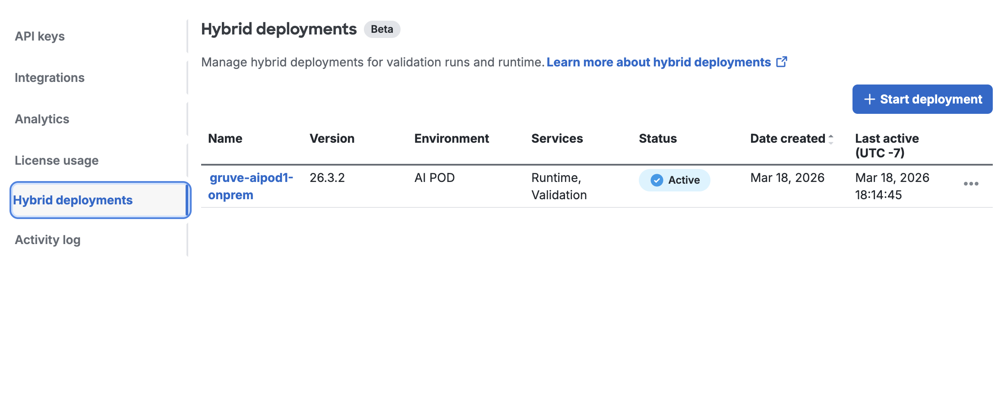
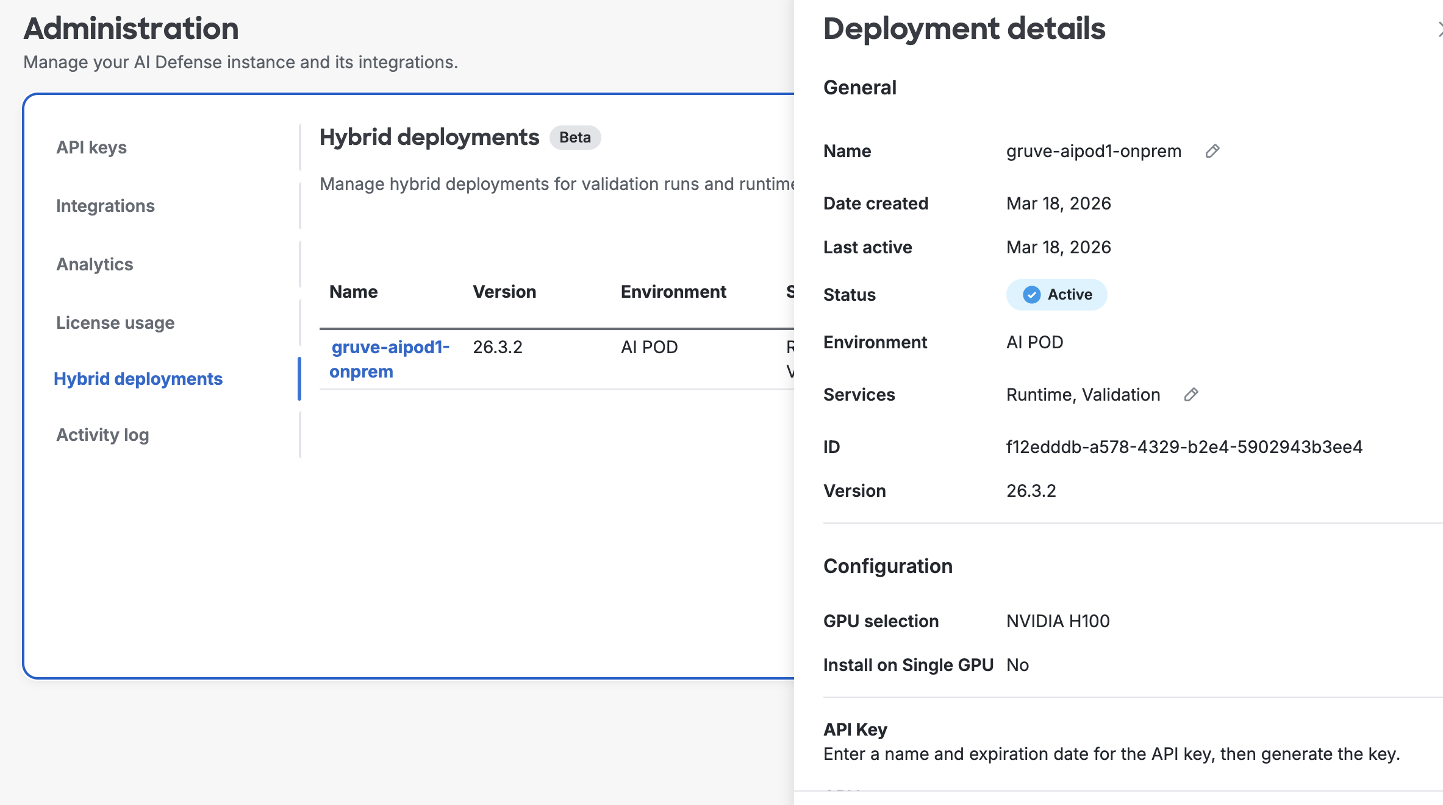

6.7 Quick No-Error Check
# This command should return NOTHING if all pods are healthy
oc get pods -n ai-defense-onprem | grep -v Running
7. Post-Installation Notes

7.1 Accessing AI Defense
AI Defense does not have a standalone browser management UI. Access is via:
- Management Portal: https://security.cisco.com (Cisco SCC - configure policies, view detections, manage connectors)
- AI Application Proxy: https://aid-rte-onprem.gruveai.com (point AI applications here to route traffic through AI Defense)
- API Inspection: https://aid-rte-onprem.gruveai.com/api/v1/inspect (query AI Defense to inspect individual prompts/responses)

7.3 Node Label Persistence
The following node labels were applied manually and must be re-applied if worker nodes are rebuilt or new worker nodes are added:
# AI Defense scheduling label
oc label node <worker-node> node_group=dps --overwrite

# LVM storage label
oc label node <worker-node> lvms-nvme=true --overwrite

WARNING
Consider adding these labels to a MachineConfig to make them permanent across node reboots and rebuilds.

7.4 Gemma Environment Variable
The TORCH_CUDA_ARCH_LIST=9.0 environment variable was set on the triton-gemma-3-4b-it deployment for H100 GPU compatibility. This is stored in the Deployment object and survives pod restarts. However, it may be overwritten by a Helm upgrade. After any AI Defense upgrade, verify and re-apply if needed:
# Verify it exists:
oc get deploy triton-gemma-3-4b-it -n ai-defense-onprem -o jsonpath='{.spec.template.spec.containers[0].env}' | jq .

# Re-apply if missing after an upgrade:
oc set env deploy/triton-gemma-3-4b-it -n ai-defense-onprem TORCH_CUDA_ARCH_LIST=9.0

7.5 Upgrading AI Defense
To upgrade AI Defense to a newer version, download a fresh installation script from the SCC portal (Administration > Hybrid Deployments > your connector > options menu > Setup guide), then run it with the IS_UPDATE flag or re-run with --apikey:
bash aidefense-connector-installation.sh --apikey <your-api-key>
# The script uses 'helm upgrade --install' so it handles both fresh installs and upgrades

7.6 Uninstalling AI Defense
helm uninstall ai-defense-onpremises -n ai-defense-onprem
oc delete namespace ai-defense-onprem

8. Quick Reference

8.1 Key Commands
Action | Command
Check all AI Defense pods | oc get pods -n ai-defense-onprem
Check AI Defense services | oc get svc -n ai-defense-onprem
Check AI Defense routes | oc get routes -n ai-defense-onprem
Check LVM storage | oc get lvmcluster -n openshift-storage
Check storage pods | oc get pods -n openshift-storage -o wide
Check PVCs | oc get pvc -n ai-defense-onprem
View pod logs | oc logs <pod-name> -n ai-defense-onprem
Describe failing pod | oc describe pod <pod-name> -n ai-defense-onprem
Helm status | helm list -n ai-defense-onprem
Restart deployment | oc rollout restart deploy/<name> -n ai-defense-onprem

8.2 Key Environment Details
Parameter | Value
AI Defense Namespace | ai-defense-onprem
AI Defense Version | 26.3.2
Connector Name | gruve-aipod1-onprem
Helm Release Name | ai-defense-onpremises
Cloud Gateway | us.cloudgw.aidefense.security.cisco.com:443
Helm Registry | chartregistry.aidefense.security.cisco.com
AI Defense URL | https://aid-rte-onprem.gruveai.com
OCP Ingress VIP | 10.6.41.17
DNS Server | 10.6.1.11
GPU Worker Node 1 | ocp-aipod1-wrk1.gruveai.com
GPU Worker Node 2 | ocp-aipod1-wrk2.gruveai.com
GPU Type | NVIDIA H100 NVL (95830MiB HBM)
Storage Class | lvms-nvme (topolvm.io)
cert-manager Version | v1.18.2

